Git 50 commands

**Setup**

Set the name and email that will be attached to your commits and tags

$ git config --global user.name "Danny Adams"

$ git config --global user.email "myemail@gmail.com"

**Starting a Project with Git**

Create a local repo (omit <directory> to initialise the current directory as a git repo)

$ git init <directory>

Download a remote repo

$ git clone <url>

**Make a Change**

Add a file to staging

$ git add <file>

Stage all files

$ git add .

Commit all staged files to git

$ git commit -m "commit message"

Add all changes made to tracked files & commit

$ git commit -am "commit message"

**Basic Git Concepts**

**main**: default development branch  
**origin**: default upstream repo  
**HEAD**: current branch  
**HEAD^**: parent of HEAD  
**HEAD~4**: great-great grandparent of HEAD

**Branches**

List all local branches. Add -r flag to show all remote branches. -a flag for all branches.

$ git branch

Create a new branch

$ git branch <new-branch>

Switch to a branch & update the working directory

$ git checkout <branch>

Create a new branch and switch to it

$ git checkout -b <newbranch>

Delete a merged branch

$ git branch -d <branch>

Delete a branch, whether merged or  
not

$ git branch -D <branch>

Add a tag to current commit (often used for new version releases)

$ git tag <tag-name>

**Merging**

Merge branch a into branch b. Add --no-ff option for no-fast-forward merge

[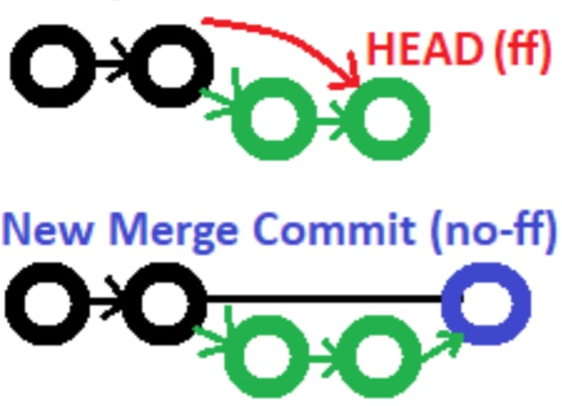](https://res.cloudinary.com/practicaldev/image/fetch/s--P-4I6vZM--/c_limit%2Cf_auto%2Cfl_progressive%2Cq_auto%2Cw_880/https:/dev-to-uploads.s3.amazonaws.com/uploads/articles/2zpi27oxqws7j39iaxs2.PNG)

$ git checkout b

$ git merge a

Merge & squash all commits into one new commit

$ git merge --squash a

**Rebasing**

Rebase feature branch onto main (to incorporate new changes made to main). Prevents unnecessary merge commits into feature, keeping history clean

[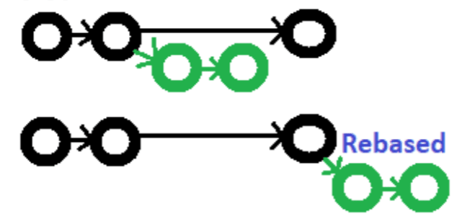](https://res.cloudinary.com/practicaldev/image/fetch/s--6pTlAeTV--/c_limit%2Cf_auto%2Cfl_progressive%2Cq_auto%2Cw_880/https:/dev-to-uploads.s3.amazonaws.com/uploads/articles/99lln9qgsiiwz8w18vdp.PNG)

$ git checkout feature

$ git rebase main

Interactively clean up a branches commits before rebasing onto main

$ git rebase -i main

Interactively rebase the last 3 commits on current branch

$ git rebase -i Head~3

**Undoing Things**

Move (&/or rename) a file & stage move

$ git mv <existing_path> <new_path>

Remove a file from working directory & staging area, then stage the removal

$ git rm <file>

Remove from staging area only

$ git rm --cached <file>

View a previous commit (READ only)

$ git checkout <commit_ID>

Create a new commit, reverting the changes from a specified commit

$ git revert <commit_ID>

Go back to a previous commit & delete all commits ahead of it (revert is safer). Add --hard flag to also delete workspace changes (BE VERY CAREFUL)

$ git reset <commit_ID>

**Review your Repo**

List new or modified files not yet committed

$ git status

List commit history, with respective IDs

$ git log --oneline

Show changes to unstaged files. For changes to staged files, add --cached option

$ git diff

Show changes between two commits

$ git diff commit1_ID commit2_ID

**Stashing**

Store modified & staged changes. To include untracked files, add -u flag. For untracked & ignored files, add -a flag.

$ git stash

As above, but add a comment.

$ git stash save "comment"

Partial stash. Stash just a single file, a collection of files, or individual changes from within files

$ git stash -p

List all stashes

$ git stash list

Re-apply the stash without deleting it

$ git stash apply

Re-apply the stash at index 2, then delete it from the stash list. Omit stash@{n} to pop the most recent stash.

$ git stash pop stash@{2}

Show the diff summary of stash 1. Pass the -p flag to see the full diff.

$ git stash show stash@{1}

Delete stash at index 1. Omit stash@{n} to delete last stash made

$ git stash drop stash@{1}

Delete all stashes

$ git stash clear

**Synchronizing**

Add a remote repo

$ git remote add <alias> <url>

View all remote connections. Add -v flag to view urls.

$ git remote

Remove a connection

$ git remote remove <alias>

Rename a connection

$ git remote rename <old> <new>

Fetch all branches from remote repo (no merge)

$ git fetch <alias>

Fetch a specific branch

$ git fetch <alias> <branch>

Fetch the remote repo's copy of the current branch, then merge

$ git pull

Move (rebase) your local changes onto the top of new changes made to the remote repo (for clean, linear history)

$ git pull --rebase <alias>

Upload local content to remote repo

$ git push <alias>

Upload to a branch (can then pull request)

$ git push <alias> <branch>